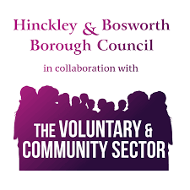
Community Volunteer Fund
Grant Application Form
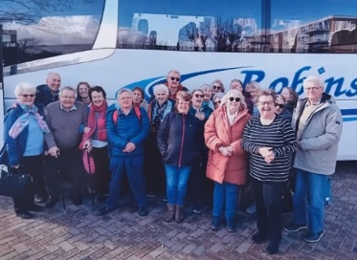
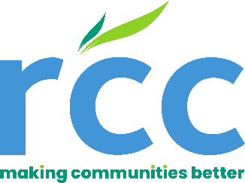
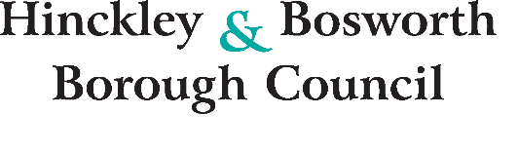
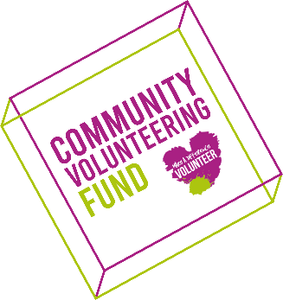
For office use only
Date Received: Date Acknowledged: Ref No.:
Name of Applicant:
Amount Applied For:
Date of Project / Activity Commencement:
Geographical Area of Project:
Grant Approved / Refused (Link to Assessment):
If Approved Payment Date:
Does the Application Link to Council Priorities:
The Community Volunteer Fund Grant Scheme supports and encourages a range of community activities, initiatives and events that meet the needs of residents and communities situated within the area of Hinckley and Bosworth Borough Council.
Making a Difference Fund Grants are from £1 up to £500 and are available for new projects or activities, which will help an organisation deliver an improved service to the community.
The Community Volunteer Fund cannot be used to fund replacement items.

Applications to the Hinckley and Bosworth Borough Council Voluntary and Community Sector Making a Difference Fund (MaD) are welcomed from organisations who are actively seeking the betterment or creation of community initiatives with the Council Borough area.
Funded by Hinckley and Bosworth Borough Council and administered by the Rural Community Council, it offers a grant of up to £500 for your community project / activity.
The Community Volunteer Fund allows organisations to apply for Community Grant Funding of between £1 up to a maximum payment of £500 to kickstart new projects within the Volunteer and Community Sector network (VCS) or to boost the impact of Network Groups across Hinckley and Bosworth Borough.
Although a wide range of community projects are eligible, we are actively encouraging applications that are in line with Hinckley and Bosworth Borough Council Priorities:
- Supporting Young People

We would especially welcome applications for projects that offer engaging, positive, and creative opportunities for young people. This could include youth groups, sports, arts activities, or music-based initiatives that help build confidence and encourage positive community engagement.

- Addressing Climate Change

We encourage applications for projects that support initiatives tackling climate change.

- Supporting Learning Difficulties and Special Educational Needs Disability Families

We welcome applications for projects providing practical, emotional, or social support to parents, carers, and families of children or adults with LD or SEND. This could involve peer support groups, accessible sessions, advice programmes, or inclusive activities that help families feel supported and connected.

- Strengthening Community Cohesion

We encourage applications for initiatives that bring diverse groups together and build positive relationships within neighborhoods. This may include intergenerational activities, cultural celebrations, community volunteering, or projects that promote shared understanding and stronger community ties.

While our funding priorities focus on specific themes, we are particularly keen to support projects that help reduce loneliness and social isolation by bringing people together, building confidence, and creating a stronger sense of belonging within communities

Whilst completing your application form please reference the attached ‘Checklist Form’ and provide all supporting documentation as this will minimize any delays in processing your application for funding.

To be eligible, you need to be a group active within Hinckley & Bosworth Borough who are working towards meeting the needs of residents and the wider community.
Circumstances where we WILL NOT provide Grant Funding support:
- Funding requests from schools and Parent Teacher Associations
- Funding requests from Parish Councils
- Funding requests from organisations which have a large cash flow surplus
- Request for funding AFTER the activity or project has taken place
- Requests for funding for religious activities
- Requests for funding for political activities or by a political organisation
- Requests for funding projects / activities which do not benefit individuals or communities residing within Hinckley and Bosworth Borough Council geographical area
- Requests for funding by private organisations
- Where there is potential reputational risk for Hinckley and Bosworth Borough Council
- Funding requests for ‘Annual Events’ i.e. Gala’s
- Funding requests for ‘Wages, Gratuities, refreshments or Personal Expenses’ will not be considered
Please be advised your application will undergo a thorough review and assessment by a designated Voluntary and Community Sector (VCS) Officer. Upon completion of initial evaluation, your submission will be forwarded to our Voluntary and Community Sector Panel Meeting for further consideration regarding grant approval.
- We would like to bring to your attention that, depending on the date of your submission, it may take up to 12 weeks to receive a decision from the Panel. We understand the importance of timely communication, and the VCS Officer responsible for your application will ensure you are kept informed of any updates throughout the review process.

For help, advice or a 1-2-1 appointment to complete this form please contact the Voluntary and Community Sector Hub Officers to arrange an appointment using either:
Email: ktaylor@ruralcc.org.uk or rstyles@ruralcc.org.uk Tel: 0800 772 0045

- Your organisation name and type
Full name as it appears on your governing document and what type e.g. community group, charity, social enterprise, CiC, uniformed groups, sports club, other.

- Tell us about your organisation and its main objectives
Give us a quick snapshot of your organisation and what it aims to achieve

- Project Name
Give the full name of your project / activity, keep it simple and snappy

- Tell us about your project
(Maximum 0f 500 words) This relates to the project / activity you are applying for only:
Please include how many persons approx.… this will benefit within your group, potential re engaging wider community and how you intend to do this:

- Which area(s) in Hinckley and Bosworth Borough will benefit most from your project / activity? Which geographical area or ward will your project / activity benefit most?

- Please tell us why your project / activity is needed
(Maximum 500 words)

- How have you identified the need for your project / activity?
e.g. carried out a consultation, completion of questionnaire?

- What outcomes do you intend your project / activity to achieve?
Please include how you intend to measure the impact of your project

- Any permissions or consents required to deliver your project / activity?
Provide evidence i.e. temporary events notices, landowner consent, specific insurances
- When do you anticipate that your project / activity will start and end?
We need to know that you have a definitive timetable in place for your project / activity
Estimated start date mm/yyyy: Estimated end date mm/yyyy:

- Project / activity costs breakdown
Please provide us with a full evidenced costed breakdown of your project / activity costs. Net of VAT means the cost before VAT is added.
*If any VAT element can be reclaimed by you, you must exclude it from your application.

Item / Description | Cost (Net of VAT)
Prices all-inclusive of VAT* | £
Total Project Costs | £
Funding Requested | £

- Which part of your project / activity do you want the Making a Difference Fund to fund?
You can apply for up to a maximum of £3000 for your project / activity

- Match Funding
Are you utilising matched funding to fund your project / activity, if so, please provide sources and supporting documents

Source of Funding | To Cover Cost of | Amount (Net of VAT)

- Organisation’s main registered address, Inc. postcode
Tell us your organisation’s main registered address including postcode. This is the address that will be used for written correspondence

- Details of Main Contact for your organisation
This should be the main person we can contact if we have any questions about your application
*These Sections are compulsory, but we will not share any of the information with the public
*Name and Title
*Position
*Address inc. postcode
*Email
*Mobile telephone
- Charity No. (if applicable)
- Company No. (if applicable)
- When was your group formed (Year)
- Are you VAT Registered?
- VAT Registration No. (if applicable)

- ORGANISATIONAL BANK DETAILS
Please complete your Organisations bank information in the section below, to enable funding claims to be paid directly into the Organisation’s bank account.

Organisation Bank Details
Name of Bank
Bank Account Name
Bank Account No.
Bank Sort Code
Building Society Ref No. (if Applicable)

- Acceptance
As Project Lead of the Organisation, I accept the Hinckley & Bosworth Volunteer & Community Sector Grant Terms and Conditions as outlined in this document. Signed Terms and Conditions must be returned within 14 days of approval, via e-mail to the Hinckley & Bosworth Volunteer & Community Sector Team at ktaylor@ruralcc.org.uk

- Applicant Acknowledgment for Hinckley & Bosworth Volunteer & Community Sector Grant

☐ As an authorised Project Lead for the Organisation I am aware and have read and understood the terms and conditions regard accepting funding from the Hinckley and Bosworth Volunteer and Community Sector as set out in the attached document. I agree to adhere by the terms and conditions as stated within.

Organisation / Group
Project / Activity Title
Signed
Print Name
Position
Date

- Any other information to support your application
Any other information that you think may help / support your application.
Attach any appropriate evidence.

17. Have you included the required documents?
Please refer to checklist accompanying this application form. Please make sure that you have answered all questions in the form before submitting to us. If you application is incomplete and is without the required information this may result in your application being delayed or even withdrawn from consideration.

18. Appeals Against Decision
If you disagree with a Grant Application decision, you can appeal. You will need to appeal in writing to ktaylor@ruralcc.org.uk . Consideration will them be made by our Grant Scheme Assessor and you will receive a decision within 28 days from receival.
Data Protection
We may share information with organisation’s or individuals with a legitimate interest in our Grant Funding Programmes. We have a duty to protect Public Funds and for that reason we may share information with other government departments, organisation’s providing matched funding or the prevention or detection of crime.
If you provide false or inaccurate information in your application or at any point in the life of the funding, we award you and fraud is identified, we will provide details to the Fraud Prevention Agencies to investigate. We might use the data you provide for research purposes. We recognise the need to maintain the confidentiality of vulnerable groups and their details will not be made public in any way, except as required by law.
On success of your project / activity, you agree to provide feedback regards your project / activity via the feedback request form within 3 months of receipt and we retain the right to advertise your project / activity in local and national media, including social media.

Freedom of Information Act
The Freedom of Information Act 2000 gives members of the public the right to request information that Hinckley and Bosworth Borough Council holds. This includes information received from third parties, such as, although not limited to grant applications, grant holders, contractors and people making a complaint. If information is requested under the Freedom of Information Act, we will release it, subject to exemptions, although we may choose to consult you first.
By ticking this box, you confirm that you understand Hinckley and Bosworth Borough Council’s obligations under the Data Protection Act 1988 to 2018 and the Freedom of Information Act 2000. You accept that as long as the Council’s actions conform to the relevant law it will not be liable for any loss or damage that your group might suffer as a result of the Council fulfilling its obligations.
☐
Date: Signed:
Email your completed application form and accompanying documents to: ktaylor@ruralcc.org.uk

